URL (Uniform Resource Locater)
Syntax:
URI = scheme ":" ["//" authority] path ["?" query] ["#" fragment]
- scheme (or protocol): how the web transmit data (e.g: http, https, ftp, …)
- query: extra data pass to the server
- fragment: a specific section within the webpage
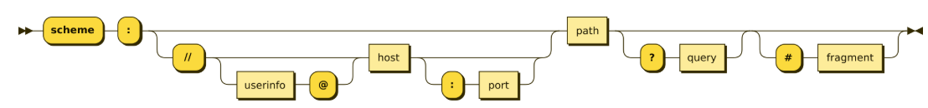

ABOUT HTTP
HTTP (Hypertext Transfer Protocol)
- HTTP is stateless
Meaning: the web server treats each transfer as an completely independent request, the web does not store previous requests. No shared memory.
HTTPS (Hypertext Transfer Protocol Secure)
- Data is encrypted, where encriptions are implemented based on SSL (Secure Sockets Layer) or TLS (Transport Layer Security)
  - SSL is a cryptographic protocol employing combinations of hashing algorithms, asymmetric encryption and symmetric encryption. However, due to some issues, it has not been used and developed since v3.0, instead using TLS nowadays.
HTTP Methods: As a representation of CRUD application
- GET: retrieves data from the server
- POST: submit data to the server
- PUT: update data in the server
- DELETE: deleta data from the server

HTTP Header fields
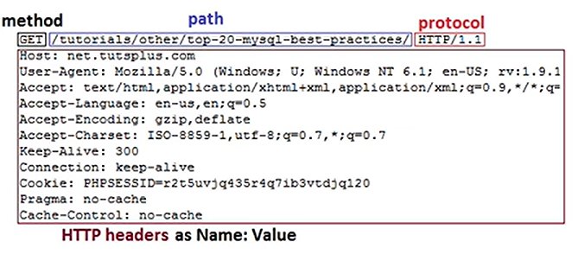
Some basics terms:
General (the connection overview):
- Request URL
- Request method: GET or PUT, …
- Remote Address: IP, …
- Status Code: BAD or HEALTHY,…
- Referrer Policy
Response (what the server sends back):
- Server
- Set-Cookie
- Content-Type
- Content-Length
- Date
Request (what your browser sends):
- Cookies
- Accept-xxx
- Content-Type
- Content-Length
- Authorization
- User-Agent
- Referrer

HTTP Status Codes
- 1xx: Informational
- 2xx: Success
- 3xx: Redirect
- 4xx: Client Error
- 5xx: Server Error

TCP/IP
- IP (Internet Protocol)
Internet Protocol Suite, commonly known as TCP/IP, is a framework for internet communication, where:
  - TCP (Transmission Control Protocol): responsible for controlling, debugging and ensuring data transmission (Transport Layer)
  - IP (Internet Protocol): responsible for locating and facilitating communications (Internet Layer)
Compare TCP/IP vs OSI model
TCP/IP model  (4 layers) | OSI model  (7 layers) | Responsibility
Application | Application  Presentation  Session | Handles user interface, data formatting, encription, and session management (e.g: HTTP, FTP, …)
Transport | Transport | Manages host-to-host communication, flow control, and realibility (e.g: TCP, UDP, …)
Internet | Network | Handles logical addressing and routing packets across the networks (e.g: IP, ICMP, …)
Link | Data Link | Formats data into frames and handles physical hardware addressing (e.g: Ethernet, Wi-fi, Mac address, …)
(Included Physical In updated TCP/IP model) | Physical | Transmit data of raw bytes signal through cables or antenna,…

Types of IP address
- Dynamic IP: IPs which can change over time
- Static IP: IPs with the value fixed

IPv4 vs IPv6
IPv4: Use 32bit to make up an IP, each octet has the value between 0 to 255
(e.g: 192.168.0.1)
- There are 4,294,967,296 cases
IPv6: It is the mose recent version of IP, using 128-bit presentation to solve the problem of exhaustion in IPv4 (e.g: 2001:0db8:85a3:0000:0000:8a2e:0370:7334)

More info:
- URL - Wikipedia
- What is SSL? | Learning Center
- Asymmetric Encryption - GeeksforGeeks
- What is a Symmetric Encryption? - GeeksforGeeks
- Transmission Control Protocol (TCP) - GeeksforGeeks
- HTTP API of java.net.http Package With Examples - GeeksforGeeks
- What are all the possible values for HTTP "Content-Type" header? - Stack Overflow

